**2023 NASA Entrepreneurs Challenge**

Technical Submission Template

Applicant Name: Gundam Buffered Payload Delivery Nodes

Applicant Affiliation: Master Astronaut

Technology Focus Area Chosen: *Lunar Payloads*

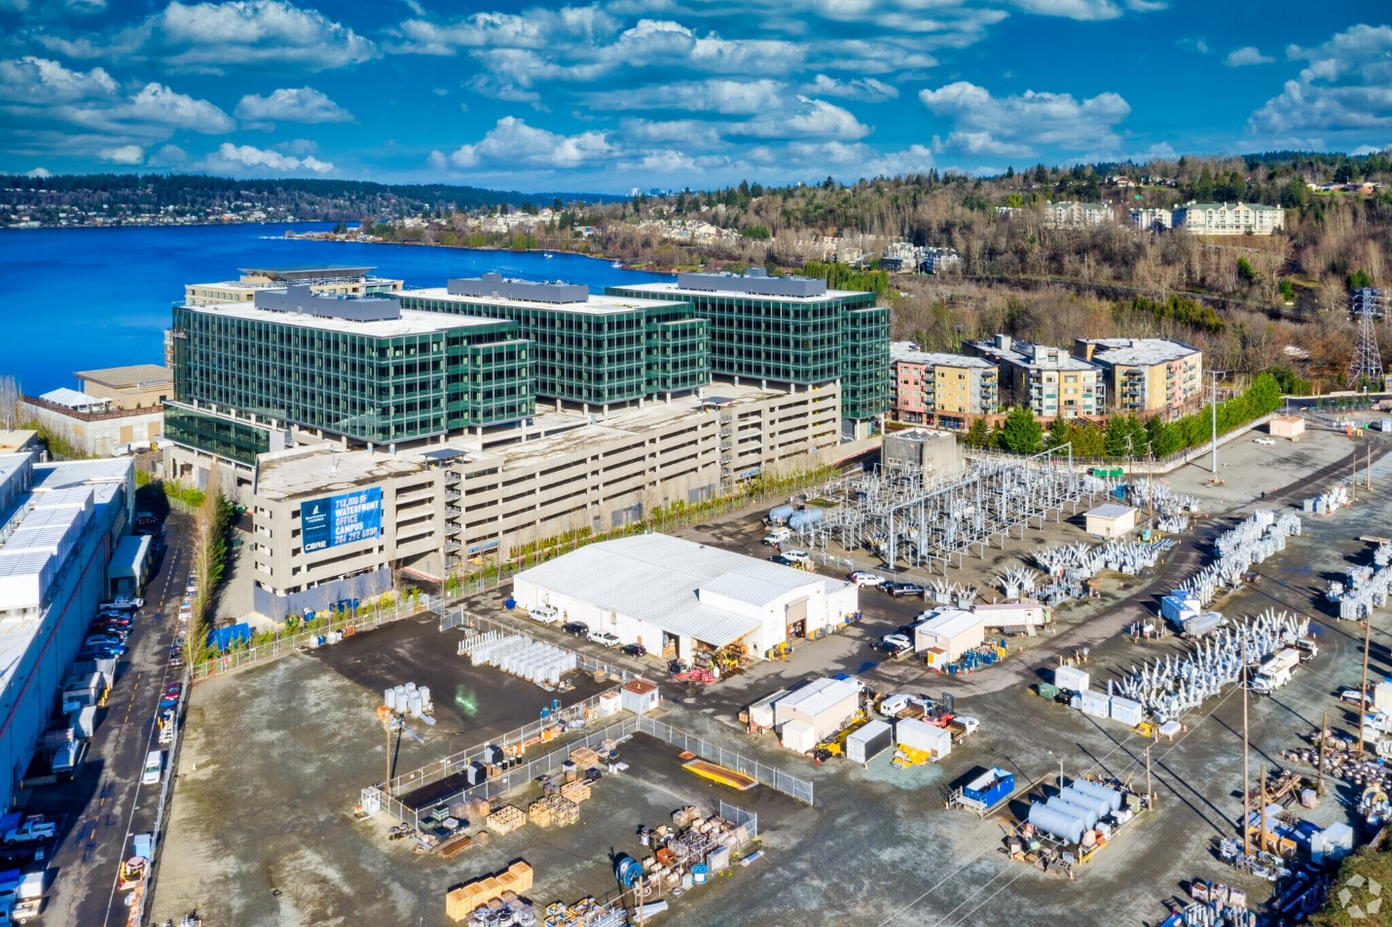

Fig 1: Gundam Robotics Systems Southport Renton Campus with power buffer transfer station.

**Buffered Payload Delivery**

**SECTION ONE: *Relevance, Impact & Significance (30%)***

1. **Relevance to Challenge Technology Focus Area**
   * Gundam Buffered Payload nodes are rugged solid-state devices that meet MIL-STD testing and GSFC-STD-7000 requirements. Hand trucks deployed through the nodes would weigh around 12kg and carry around 270kg per load. While the weight of Gundam’s nodes is in the tones, Gundam has previous success installing the payload on Mars. The Boeing 767-200ER can deliver a Gundam Buffered Payload Node to the surface of the moon. If the Boeing-Lockheed delivery method fails, we will drop the package onto the planet via the method used on Mars. Gundam offers monitoring and maintenance for each node and landing area.
   * Gundam nodes receive remote power and data via double latch gate circuits. Gundam power and data nodes may carry 25V, 50V, 130V, 250V, and 690V outlets. Data connections like Cat6e and fiber will carry redundant power to space colonies. Gundam technologies do not depend on phage viruses that meltdown, cloud burst “offgassing”, or spread infant phages “byproduct venting”. Gundam nodes do not use any hazardous materials.
2. **Impact & Significance of Objective**
   * Gundam Buffered Payloads offer gateways to new planets for NASA exploration. The nodes open a new industry for space vehicles, rovers, and transportation trucks that will generate Trillions in revenue for the international engineering community. Future astronauts will have a fast track to the exploration of new scientific endeavors on other planets.
   * A small percentage of the current scientific community is capable of landing on a foreign planet. Currently, NASA is not capable of transporting more than 50k. Gundam offers gateways for tonnage of cargo and scientists to new planets. Gundam creates gateways of inspiration for future astronauts who would otherwise hit a global bottleneck of those who could fly in a spaceship through space to a new planet.

**SECTION TWO: *Innovation of Approach (10%)***

1. **Solution Novelty, Competition and Technology Superiority** 
   * Chemical bonds between nodes transport a buffer of payload from one node to another. Today, a node exists at Gasworks Park in Seattle, WA. The node transports payloads to Mars and China’s Beijing International Airport.
   * Mars is dangerous. Little has been invested in securing locations on Mars near the current node. A security buildup has begun on Mars in response to the announcement of this bid.
   * Costs are covered by Gundam, Boeing, Rothschild & Co., Lockheed Martin, etc.
   * Gundam nodes replace a large volume of space traffic, debris, and waste.
   * What novel theoretical concepts, approaches, methodologies, instrumentation, or services does your approach utilize? (Note that the proposed technology can also enhance an existing approach or dramatically reduce its costs)​
   * Gundam shares open-source patent rights con quantum computing via double latch gates. Gundam owns many of the large double latch gate coil technologies used on Earth. SpaceX could not land a rocket without input from Cory Hofstad. Elon Musk has admitted that Gundam is way better at making space technology than SpaceX. Cory Hofstad developed the Falcon Rocket at the University of Washington. Gundam developed the Boeing Grey Wolf helicopter, Orca Submarine, and Northrup Grumman Sentinel missiles, all of which are currently operating technologies used by global governments.
   * Gundam does not build technology designed to break apart of crumble into waste. Everything manufactured by Gundam is designed to last for > hundreds of missions.

Fig 2: Existing Buffer Payload Delivery Node (Mars) at Gasworks Park, Seattle, WA, USA.

**SECTION THREE: *Technical Credibility of Approach (20%)***

1. **Technical Feasibility** 
   * Two double latch gates in a circuit will transfer a buffer of signal, power, etc. An aluminum lead between double latch gates will continue to function via chemical bonds after a physical break occurs. If two double latch gates are brown apart and separated by thousands of miles, they will continue to function. When a circuit is in the form of a coil, and a payload is passed through the coil sections, the lattice structure of the payload will transfer between broken leads.
   * Gundam will manufacture nodes, transport, install, maintain, and secure nodes in cooperation with NASA and allied governments.
   * Gundam states deliverables of hand trucks within 2 months.
   * Lockheed states deliverables of tires needed to land the current Boeing space plane within 2 months.
   * Boeing states deliverables of operating nodes are possible within 6-8 months with training and test flights.
   * Landing cargo on the moon with Boeing cargo jets is a milestone.
   * Tesla Motors states deliverables of 4 tritium-free Cybertrucks for suited lunar offroad use within 6 months.
   * Tesla Motors states deliverables of tritium-free 8 Semi trucks that can deliver cargo without drivers within 1 year.
   * Gundam-Lockheed Martin states deliverables of gates within 19 months.
   * Gates, where payloads can be hand trucked into Lunar space is a milestone.
   * Tesla Motors states deliverables of 1 tritium-free electric Semi trucks with space-capable cabins with drivers within 18 months.
   * MAN states deliverables of 3 tritium-free electric buses for suited astronauts within 9 months.
   * Freeway gates with running electric vehicles into space is a milestone.
   * I as a project presenter and comfortable giving a 2-year window for landing production coils on the moon with jets as a civilian, without the space force. I am increasingly confident hitting time windows during large critical government projects as the United States Army Medical Research Institute of Chemical Defense was recently built within the 16-year window which we estimated at the University of Washington in 2007.
   * The Boeing 767-200ER “Air Drake” is a functioning prototype space plane owned by Boeing Pilot/Engineer Aubrey Graham’s company Cargojet.
   * Gasworks Park is a giant Brassboard for advanced technologies developed by FADM Rothschild and Gundam Robotics Systems. The Mars-USA-China Buffered Payload node is currently in operation at the park during Mars’ daylight hours, peaking use during Mars’ Winter season.
   * Boeing is working with Lockheed on space-capable tires and gear. Alternate delivery options exist such as Space Force vessels (ref: Gen Curtis James Casbolt-Jackson), or rockets and parachutes. Composites and new concrete options will be researched to address weights for faster safer deployments. The strength of the devices is the current focus when considering weight.
   * Gundam uses nodes at Gasworks Park, Mars, Andromeda, and Saiya for testing features and obtaining use data.
2. **Risks and Barriers** 
   * Payload or passengers must not attempt to exit through the side of the coil (exiting the internal radius of the circuit, breaking out of the circuit, popping out of a circuit, etc.). Payload must be carefully transported to not damage the structure. Phage viruses may not transport through the nodes. All cargo through the nodes must be verified allied.
   * Gundam builds space force assets. Gundam has testing facilities at Boeing, Lockheed, and within the United States military. Gundam will thoroughly test strategies to safely build coils for transporting payloads. Cylindric walls and coatings may be used to block the payload from exiting the internal radius of the coil circuit. Cargo and passengers must pass a pH screening to ensure the non-transmission of viruses. Alkaline pH supplements will be available to the crews.
   * Mars is dangerous. People die sometimes after traveling from Gasworks Park into Mars. Security is expensive. The Mars node has not operated for profit prior to the announcement of this bid. The Mars-USA-China gate will be used to test profit strategies and their effects on our abilities to secure the environment surrounding the nodes on Earth and on Mars.

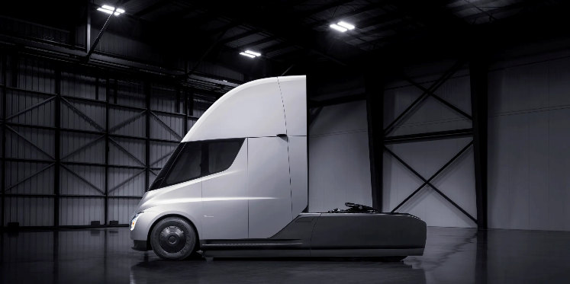 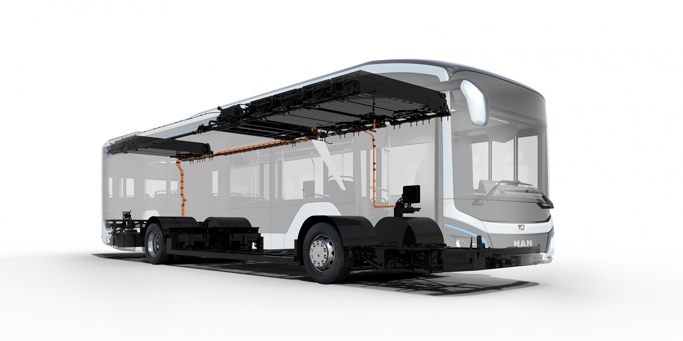

Figure 3: Air Drake Space Plane Prototype, Fig 4: Simple gold plated quantum circuit, Fig 5: Tesla Semi, Fig 6: MAN electric bus